## Image result for united college of engineering and researchlogo

## SIX WEEK OF SUMMER TRAINING REPORT

## ON

## WEB DEVELOPMENT Using REACT FROM COURSERA

Submitted by: Divya Pandey

Sumbitted in Partial Fulfillment For the Fourth Year Summer Training Of

Bacherlor’s of Technology

In

Computer Science & Engineering

from

United College Of Engineering and Research

Naini,Prayagraj

University Roll No.:1801010041

Section:7A

Panel Members-:Anjali Mishra and Divya Pandey

Date of Submission-:6/12/2021

Title

Web Development Using React

Certificate



## ACKNOWLEDGEMENT

## I am grateful to Coursera for giving me opportunity to carry out the project work in the area of console based portal designing during my training.Deepest thanks to the institute JOHN HOPKINS UNIVERSITY for their guidance, monitoring, constant encouragement and correcting various assignments of ours with attention and care. They have taken pain to go through the project and training sessions and make necessary corrections as when needed and we are very grateful for that.

### DIVYA PANDEY.

Abstract

ReactJS is JavaScript library used for building reusable UI components. According to React official documentation, following is the definition −

React is a library for building composable user interfaces. It encourages the creation of reusable UI components, which present data that changes over time. Lots of people use React as the V in MVC. React abstracts away the DOM from you, offering a simpler programming model and better performance. React can also render on the server using Node, and it can power native apps using React Native. React implements one-way reactive data flow, which reduces the boilerplate and is easier to reason about than traditional data binding.

## React Features

* **JSX** − JSX is JavaScript syntax extension. It isn't necessary to use JSX in React development, but it is recommended.
* **Components** − React is all about components. You need to think of everything as a component. This will help you maintain the code when working on larger scale projects.

Content

* Introduction to React Js.
* Component,State,Props.
* Life Cycle of Component.
* Pros and Cons.
* Demonstration.

What is REACT ?

* A Javascript library for Building User Interfaces.
* Renders your UI and responds to events.
* It also uses the concept called Virtual DOM,creates and in-memory data structure cache,enumerates the resulting differences,and then updates the browser’s displayed DOM efficiently.
* One of the unique features of React.js is not only it can perform on the client side,but it can also be rendered on the server side,and they can work together.



WHAT IS REACT? – VIRTUAL DOM
• Manipulate DOM is high cost.
• React first assembles the entire structure
of your app in-me...

JSX

In React, instead of using regular JavaScript for templating, it uses JSX. JSX is a simple JavaScript that allows HTML quoting and uses these HTML tag syntax to render subcomponents. HTML syntax is processed into JavaScript calls of React Framework. We can also write in pure old JavaScript.

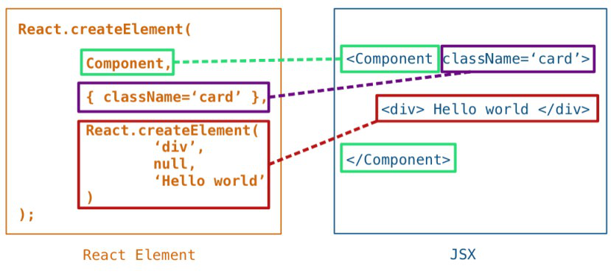

Component and Props

Props stand for "**Properties**." They are **read-only** components. It is an object which stores the value of attributes of a tag and work similar to the HTML attributes. It gives a way to pass data from one component to other components. It is similar to function arguments. Props are passed to the component in the same way as arguments passed in a function.

Props are **immutable** so we cannot modify the props from inside the component. Inside the components, we can add attributes called props. These attributes are available in the component as **this.props** and can be used to render dynamic data in our render method.When you need immutable data in the component, you have to add props to **reactDom.render()** method in the **main.js** file of your ReactJS project and used it inside the component in which you need. It can be explained in the below example

1. **import** React, { Component } from 'react';
2. **class** App **extends** React.Component {
3. render() {
4. **return** (
5. <div>
6. <h1> Welcome to { **this**.props.name } </h1>
7. <p> <h4> Javatpoint is one of the best Java training institute in Noida, Delhi, Gurugram, Ghaziabad and Faridabad. </h4> </p>
8. </div>
9. );
10. }
11. }
12. export **default** App;

COMPONENT - STATE
class TodoInput extends React.Component {
constructor(props) {
super(props); //Call this function becaus...

Pros and Cons of React.JS

### Advantage of ReactJS

**1. Easy to Learn and Use**

ReactJS is much easier to learn and use. It comes with a good supply of documentation, tutorials, and training resources. Any developer who comes from a JavaScript background can easily understand and start creating web apps using React in a few days.

**2. Creating Dynamic Web Applications Becomes Easier**

To create a dynamic web application specifically with HTML strings was tricky because it requires a complex coding, but React JS solved that issue and makes it easier. It provides less coding and gives more functionality.

**3. Reusable Components**

A ReactJS web application is made up of multiple components, and each component has its own logic and controls. These components are responsible for outputting a small, reusable piece of HTML code which can be reused wherever you need them. The reusable code helps to make your apps easier to develop and maintain..

**4. Performance Enhancement**

ReactJS improves performance due to virtual DOM. The DOM is a cross-platform and programming API which deals with HTML, XML or XHTML. Most of the developers faced the problem when the DOM was updated, which slowed down the performance of the application. ReactJS solved this problem by introducing virtual DOM.

**5. The Support of Handy Tools**

React JS has also gained popularity due to the presence of a handy set of tools. These tools make the task of the developers understandable and easier. The React Developer Tools have been designed as Chrome and Firefox dev extension and allow you to inspect the React component hierarchies in the virtual DOM. It also allows you to select particular components and examine and edit their current props and state.

**6. Known to be SEO Friendly**

Traditional JavaScript frameworks have an issue in dealing with SEO. The search engines generally having trouble in reading JavaScript-heavy applications. Many web developers have often complained about this problem. ReactJS overcomes this problem that helps developers to be easily navigated on various search engines. It is because React.js applications can run on the server, and the virtual DOM will be rendering and returning to the browser as a regular web page.

### Disadvantage of ReactJS

**1. The high pace of development**

The high pace of development has an advantage and disadvantage both. In case of disadvantage, since the environment continually changes so fast, some of the developers not feeling comfortable to relearn the new ways of doing things regularly. It may be hard for them to adopt all these changes with all the continuous updates. They need to be always updated with their skills and learn new ways of doing things.

**2. View Part**

ReactJS Covers only the UI Layers of the app and nothing else. So you still need to choose some other technologies to get a complete tooling set for development in the project.

References

* [www.reactjs.org](http://www.reactjs.org)
* [www.javatpoint.com](http://www.javatpoint.com)
* [www.w3schools.com](http://www.w3schools.com)
* [www.coursers.com](http://www.coursers.com)